**Database**: Airport

Company table has ID and name of the company, which transports passengers. Trip table has information about trips: trip number, company ID, plane type, departure city, arrival city, departure time and arrival time. The passenger table has passenger's ID and passenger's name. Pass_in_trip table has information about the flights: trip number, departure date (day), passenger's ID and his place during the flight.

* Company (ID_comp, name)
* Trip (trip_no, id_comp, plane, town_from, town_to, time_out,time_in)
* Passenger (ID_psg, name)
* Pass_in_trip (trip_no, date, ID_psg, place)

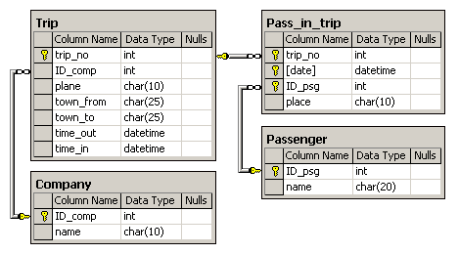

Note:

* Every day, one or more trips happen.
* Duration of all the flights is less than a calendar-day (24 hours).
* Time and date of all trips are considered to be in the same time zone.
* The departure time and the arrival time are stored to within a minute.
* There can be 2 passengers with the same names (for example, Bruce Willis).
* Relationships and restrictions are shown in the data schema.

1. Find the names of the different passengers, who flew more than once in the same seat.

**Set: Name, Place, No of Trips**

select p.name,pt.place,

count(pt.place)

no_of_trips from

[Airport].[Passenger] p join

[Airport].[Pass_in_trip] pt

on p.id_psg=pt.id_psg

group by p.name,pt.place

having count(pt.place)>1

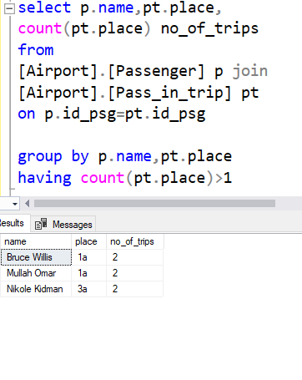

1. For the days between 2003-04-01 and 2003-04-07, find the number of trips from the town Rostov.

**Result set: date, number of trips**

select pt.date,count(pt.trip_no) as number_od_trips

from [Airport].[Pass_in_trip] pt

join

[Airport].[Trip] t

on pt.trip_no=t.trip_no

where t.town_from='Rostov' and

(pt.date between '2003-04-01' and '2003-04-07' )

group by pt.date

1. List the passengers who have visited Moscow more than once.  
   **Result set: name, number of visits to Moscow.**

select p.name,count(p.name)as number_of_times

from

[Airport].[Passenger] p join

[Airport].[Pass_in_trip] pt

on p.id_psg=pt.id_psg join

[Airport].[Trip] t on pt.trip_no=t.trip_no

where t.town_from='Moscow'

group by p.name

1. For each company, find the number of passengers (if any) who travelled in April 2003 by every ten-day period.

**Result set: name, 1-10, 11-20, 21-30**

select c.name,pt.date,

case when

pt.date between '2003-04-01' and '2003-04-10' then count(pt.

id_psg

)end as

'1-10' ,case when

pt.date between '2003-04-11' and '2003-04-20' then count(pt.

id_psg

)end as

'11-20',case when

pt.date between '2003-04-21' and '2003-04-30' then count(pt.

id_psg

)end as

'21-30'

from

[Airport].[Company] c join

[Airport].[trip] t

on c.id_comp=t.id_comp join

[Airport].[Pass_in_trip] pt

on pt.trip_no=t.trip_no join

[Airport].[Passenger] p on p.id_psg=pt.id_psg

group by c.name,pt.date

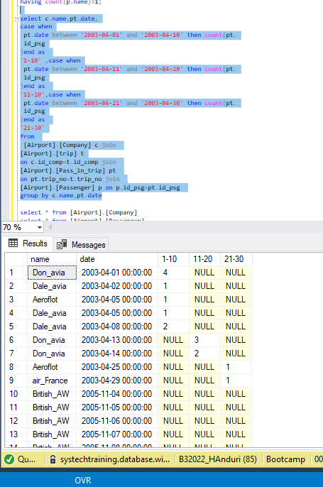

1. Determine the total number of routes served by the flight(s) which has the maximum number of trips. A - B and B - A are to be considered as DIFFERENT routes.

**Result Set: Number of Trips**

1. Among the clients who only use a single company, find the passengers who have flown the most.

**Result set: passenger name, number of trips.**

select p.name,count(c.name)

as 'number of trips'

from [Airport].[Passenger] p join

[Airport].[Pass_in_trip] pt on

p.id_psg=pt.id_psg

join

[Airport].[Trip] t on t.trip_no=pt.trip_no join

[Airport].[Company] c

on c.id_comp=t.id_comp

group by p.name

having count(c.name)=1

7.Find the passengers who spent the most amount of time in flight than others.

**Result set: passenger name, total flying time in minutes.**

